Lap5

Task Detail Sketch and Navigation Map
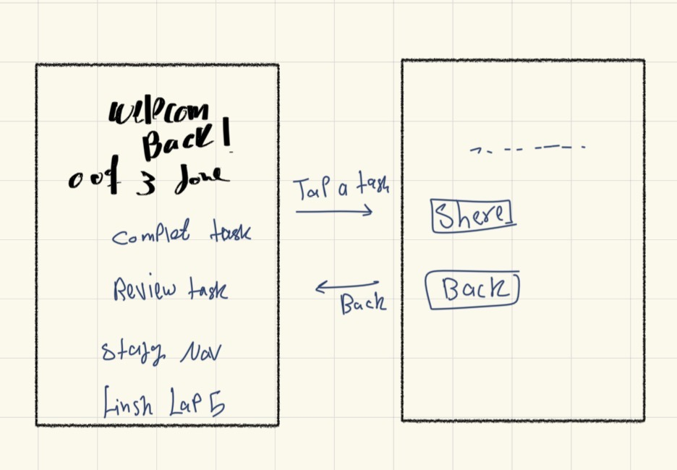

Required Questions and Answers

What does the task detail screen show?
It shows the selected task title, a Share button, and a Back button.

What information does the screen need to open?
It needs the title of the selected task.

What can the user do on this screen?
The user can share the task title through the Android share sheet or return to the home screen.

Navigation
Home opens Task Detail when a task is tapped. Back returns to Home.

Home Screen
The home screen displays three study tasks and the completion counter.
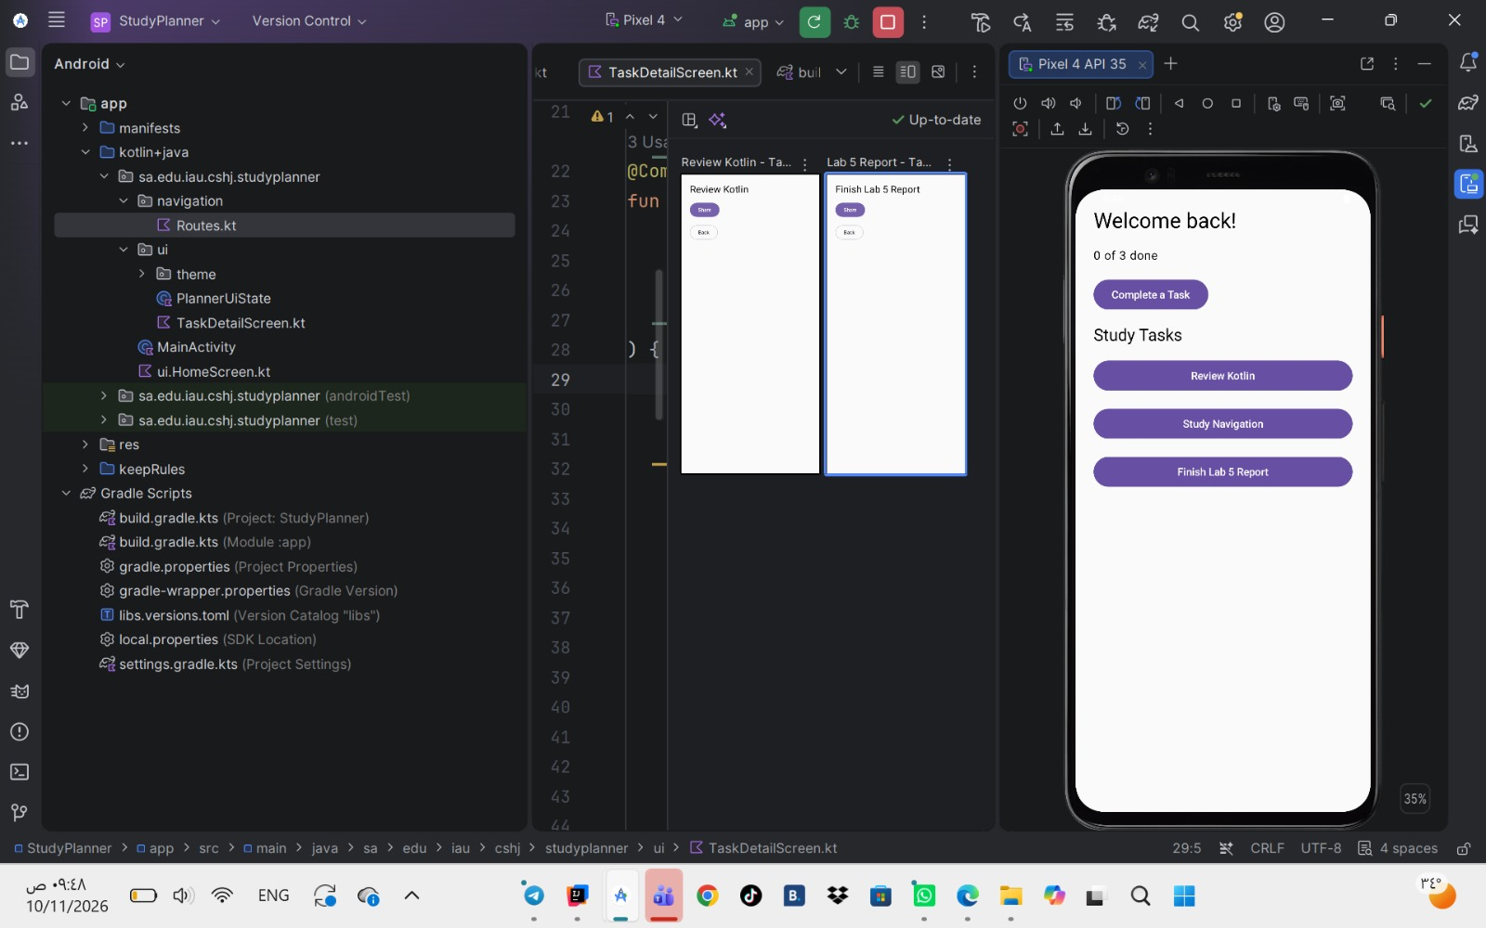

Task Detail Previews
Two previews use different task titles: Review Kotlin and Finish Lab 5 Report.
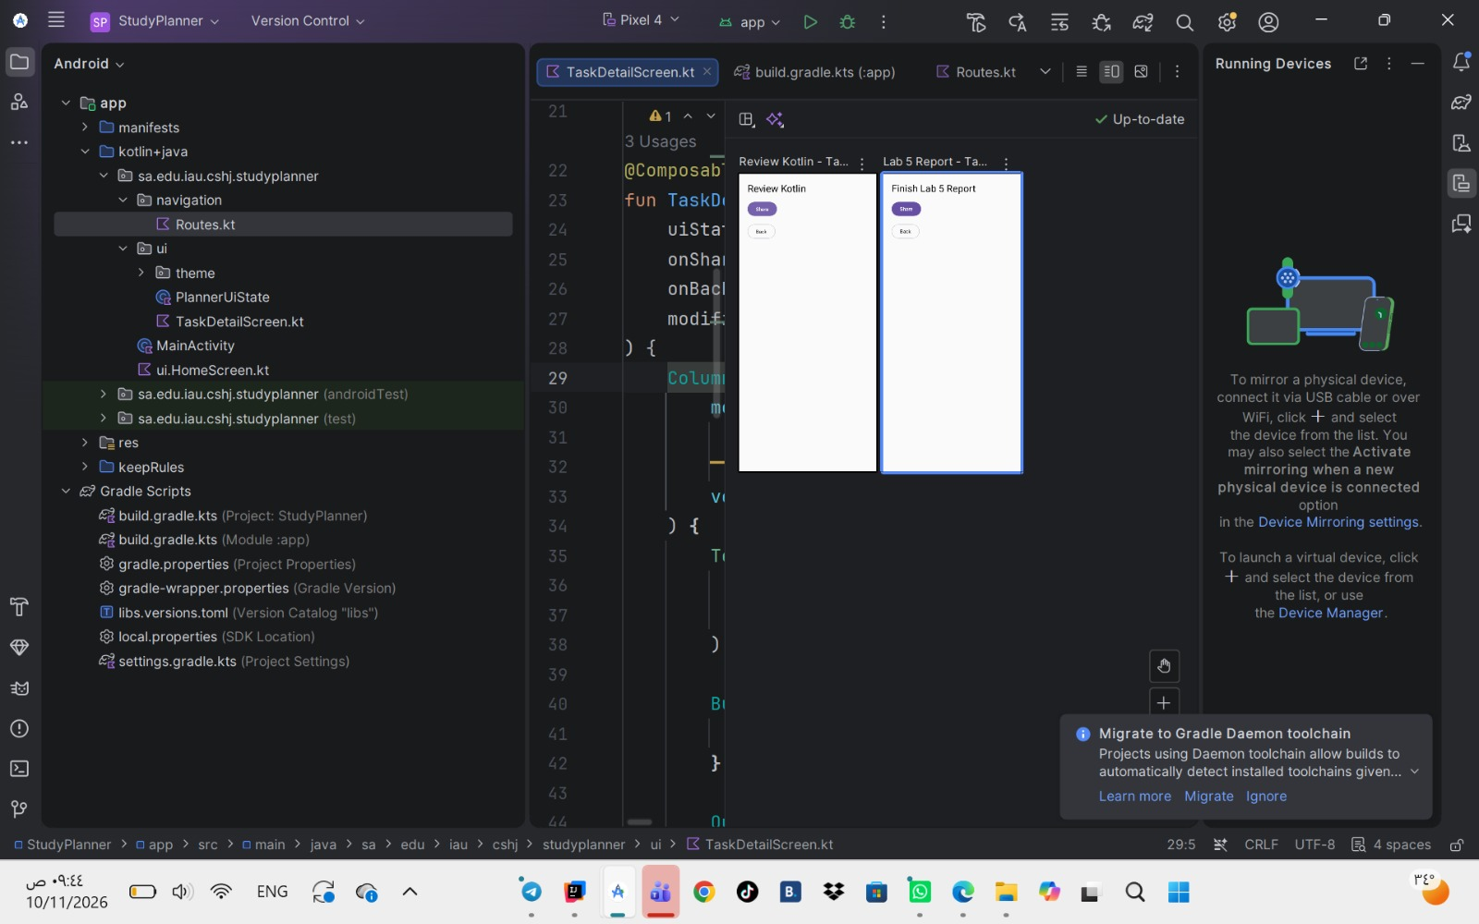

Share Sheet
The share sheet contains the selected task title in the text: Today I'm studying: Review Kotlin.
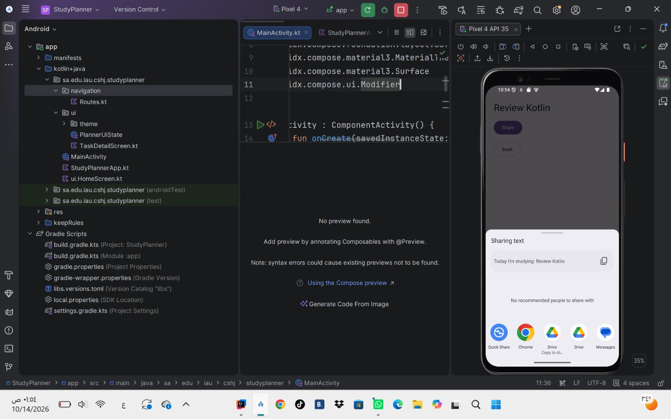

PlannerUiState.kt
package sa.edu.iau.cshj.studyplanner.ui

data class PlannerUiState(
val greeting: String = "Welcome back!",
val totalTasks: Int = 5,
val completedTasks: Int = 0,
val tasks: List<String> = emptyList()
)

ui.HomeScreen.kt
package sa.edu.iau.cshj.studyplanner.ui

import androidx.compose.foundation.layout.*
import androidx.compose.material3.*
import androidx.compose.runtime.*
import androidx.compose.ui.Modifier
import androidx.compose.ui.tooling.preview.Preview
import androidx.compose.ui.unit.dp

@Composable
fun PlannerHomeScreen(
uiState: PlannerUiState,
onCompleteTask: () -> Unit,
onTaskClick: (String) -> Unit,
modifier: Modifier = Modifier
) {
Column(
modifier = modifier
.fillMaxSize()
.padding(24.dp),
verticalArrangement = Arrangement.spacedBy(16.dp)
) {
Text(
text = uiState.greeting,
style = MaterialTheme.typography.headlineMedium
)
Text(
text = "${uiState.completedTasks} of ${uiState.totalTasks} done",
style = MaterialTheme.typography.bodyLarge
)
Button(
onClick = onCompleteTask,
enabled = uiState.completedTasks < uiState.totalTasks
) {
Text("Complete a Task")
}
Text(
text = "Study Tasks",
style = MaterialTheme.typography.titleLarge
)
uiState.tasks.forEach { title ->
Button(
onClick = { onTaskClick(title) },
modifier = Modifier.fillMaxWidth()
) {
Text(title)
}
}
}
}

@Composable
fun PlannerHomeRoute(
onTaskClick: (String) -> Unit = {}
) {
var uiState by remember {
mutableStateOf(
PlannerUiState(
totalTasks = 3,
tasks = listOf(
"Review Kotlin",
"Study Navigation",
"Finish Lab 5 Report"
)
)
)
}
PlannerHomeScreen(
uiState = uiState,
onCompleteTask = {
if (uiState.completedTasks < uiState.totalTasks) {
uiState = uiState.copy(
completedTasks = uiState.completedTasks + 1
)
}
},
onTaskClick = onTaskClick
)
}

@Preview(showBackground = true, name = "Nothing Done")
@Composable
private fun PlannerHomeScreenPreviewEmpty() {
MaterialTheme {
PlannerHomeScreen(
uiState = PlannerUiState(
completedTasks = 0,
totalTasks = 3,
tasks = listOf(
"Review Kotlin",
"Study Navigation",
"Finish Lab 5 Report"
)
),
onCompleteTask = {},
onTaskClick = {}
)
}
}

@Preview(showBackground = true, name = "All Completed")
@Composable
private fun PlannerHomeScreenPreviewFull() {
MaterialTheme {
PlannerHomeScreen(
uiState = PlannerUiState(
completedTasks = 3,
totalTasks = 3,
tasks = listOf(
"Review Kotlin",
"Study Navigation",
"Finish Lab 5 Report"
)
),
onCompleteTask = {},
onTaskClick = {}
)
}
}

TaskDetailScreen.kt
package sa.edu.iau.cshj.studyplanner.ui

import android.content.Intent
import androidx.compose.foundation.layout.Arrangement
import androidx.compose.foundation.layout.Column
import androidx.compose.foundation.layout.fillMaxSize
import androidx.compose.foundation.layout.padding
import androidx.compose.material3.Button
import androidx.compose.material3.MaterialTheme
import androidx.compose.material3.OutlinedButton
import androidx.compose.material3.Text
import androidx.compose.runtime.Composable
import androidx.compose.ui.Modifier
import androidx.compose.ui.platform.LocalContext
import androidx.compose.ui.tooling.preview.Preview
import androidx.compose.ui.unit.dp

data class TaskDetailUiState(
val title: String = ""
)

@Composable
fun TaskDetailScreen(
uiState: TaskDetailUiState,
onShareClick: () -> Unit,
onBackClick: () -> Unit,
modifier: Modifier = Modifier
) {
Column(
modifier = modifier
.fillMaxSize()
.padding(24.dp),
verticalArrangement = Arrangement.spacedBy(16.dp)
) {
Text(
text = uiState.title,
style = MaterialTheme.typography.headlineMedium
)
Button(onClick = onShareClick) {
Text("Share")
}
OutlinedButton(onClick = onBackClick) {
Text("Back")
}
}
}

@Composable
fun TaskDetailRoute(
title: String,
onBackClick: () -> Unit
) {
val context = LocalContext.current
TaskDetailScreen(
uiState = TaskDetailUiState(title = title),
onShareClick = {
val send = Intent(Intent.ACTION_SEND).apply {
putExtra(
Intent.EXTRA_TEXT,
"Today I'm studying: $title"
)
type = "text/plain"
}
context.startActivity(
Intent.createChooser(send, "Share via")
)
},
onBackClick = onBackClick
)
}

@Preview(showBackground = true, name = "Review Kotlin")
@Composable
private fun TaskDetailPreviewKotlin() {
MaterialTheme {
TaskDetailScreen(
uiState = TaskDetailUiState(
title = "Review Kotlin"
),
onShareClick = {},
onBackClick = {}
)
}
}

@Preview(showBackground = true, name = "Lab 5 Report")
@Composable
private fun TaskDetailPreviewReport() {
MaterialTheme {
TaskDetailScreen(
uiState = TaskDetailUiState(
title = "Finish Lab 5 Report"
),
onShareClick = {},
onBackClick = {}
)
}
}

Routes.kt
package sa.edu.iau.cshj.studyplanner.navigation

import kotlinx.serialization.Serializable

@Serializable
object PlannerHome

@Serializable
data class TaskDetail(val title: String)

StudyPlannerApp.kt
package sa.edu.iau.cshj.studyplanner

import androidx.compose.runtime.Composable
import androidx.navigation.compose.NavHost
import androidx.navigation.compose.composable
import androidx.navigation.compose.rememberNavController
import androidx.navigation.toRoute
import sa.edu.iau.cshj.studyplanner.navigation.PlannerHome
import sa.edu.iau.cshj.studyplanner.navigation.TaskDetail
import sa.edu.iau.cshj.studyplanner.ui.PlannerHomeRoute
import sa.edu.iau.cshj.studyplanner.ui.TaskDetailRoute

@Composable
fun StudyPlannerApp() {
val navController = rememberNavController()
NavHost(
navController = navController,
startDestination = PlannerHome
) {
composable<PlannerHome> {
PlannerHomeRoute(
onTaskClick = { title ->
navController.navigate(TaskDetail(title))
}
)
}
composable<TaskDetail> { backStackEntry ->
val task = backStackEntry.toRoute<TaskDetail>()
TaskDetailRoute(
title = task.title,
onBackClick = {
navController.popBackStack()
}
)
}
}
}

MainActivity.kt
package sa.edu.iau.cshj.studyplanner

import android.os.Bundle
import androidx.activity.ComponentActivity
import androidx.activity.compose.setContent
import androidx.compose.foundation.layout.Box
import androidx.compose.foundation.layout.fillMaxSize
import androidx.compose.foundation.layout.safeDrawingPadding
import androidx.compose.material3.MaterialTheme
import androidx.compose.material3.Surface
import androidx.compose.ui.Modifier

class MainActivity : ComponentActivity() {
override fun onCreate(savedInstanceState: Bundle?) {
super.onCreate(savedInstanceState)
setContent {
MaterialTheme {
Surface(
modifier = Modifier.fillMaxSize()
) {
Box(
modifier = Modifier
.fillMaxSize()
.safeDrawingPadding()
) {
StudyPlannerApp()
}
}
}
}
}
}

build.gradle.kts Module app
Additions to the existing file. Keep the existing plugins and dependencies.

Inside plugins
kotlin("plugin.serialization") version "2.2.10"

Inside dependencies
implementation("androidx.navigation:navigation-compose:2.10.2")
The serialization plugin version must match the Kotlin version in libs.versions.toml.

AI Use and Disclosure
I used ChatGPT and Google Gemini to help me complete this assignment. used ChatGPT to understand the assignment requirements, fix code errors, and organize the report. used Google Gemini to help write the code.

